**From EC2 dash board find Snapshots:**

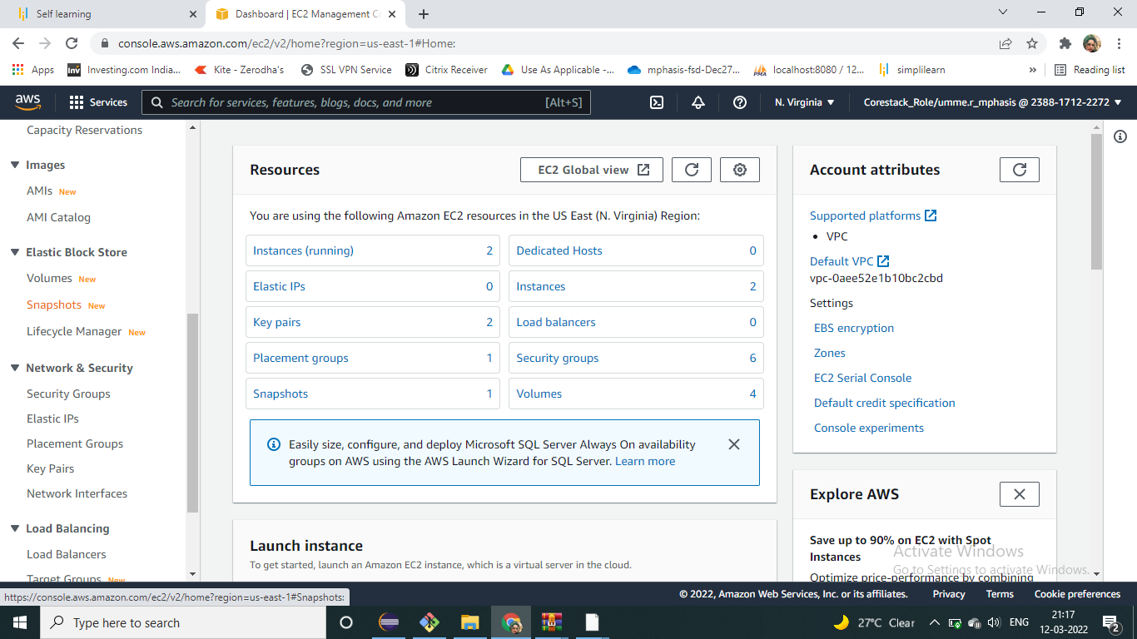

**Snap shot details:**

